* **<h1 style="color:blue;margin-left:30px;">**
* **html {**

**font-size: 16px;**

**}**

* **<link rel="stylesheet" type="text/css" href="style.css"/> това вече не е нужно**
* **Types of selectors:**

1. **Primary - define the elements to which a set of   
   CSS rules apply -** * - selects everything
2. **Nested Selectors - more than one simple selector**
3. **Pseudo Selectors - relative to element   
   content or state**

* **An inline element does not start on a new line and only takes   
  up as much width as necessary**
* **<span> is inline element**

**Its shape is not always rectangular**

**Can be split across multiple lines**

* **Inline-block elements are similar to inline elements, except  
  they can have padding and margins added on all four sides**

**Rectangles arranged one after another**

**Just like words in a sentence**

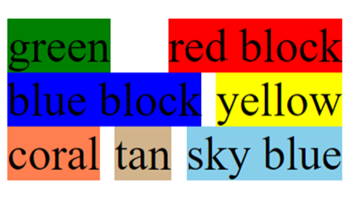

* **The CSS box model is essentially a box that wraps  
  around every HTML element**

**It consists of:**

**Margins - Area outside the border. It is transparent**

**Borders - Border that goes around the   
padding and content**

**Padding - Area around the content  
It is transparent**

**Content - Where text and images appear**

* **If you forget to tell what  
  kind of border you want   
  (in this case "solid"), it will   
  not be displayed at all**
* **In CSS, there are two types of font family names:**

**generic family - a group of font families with a similar look**

**font family - a specific font family**

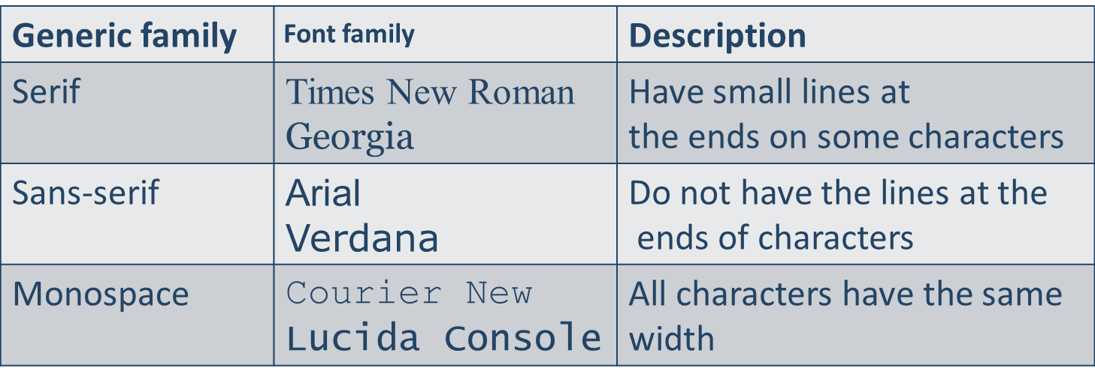

* End with a **generic** **family**, to let the browser pick a similar font in   
  the generic family, if no other fonts are available
* The **font-size** property sets the **size** of the **text** - **px**, **em**, **rem**
* The **font-weight** property sets the **weight** of the **text** - **normal**, **bold**, **lighter**, **bolder**
* The **font-style** property sets the **style** of the **text** - **italic**, **normal**
* The **color property** is used to set the color of the text

The color is specified by:

a color name - like "**red**"

a HEX value - like "**#ff0000**"

an RGB value - like "**rgb(255,0,0)**"